Bugs and Fixes v2.5

*Freddy’s Fast Food*

While programming my ordering system for “Freddy’s Fast Food” I ran into a few bugs and in this document I have a few of those bigs listed along with my solution to them.

This collection off bug is small as I did not run into many bugs along the way

Bug 1 - *case insensitive input*

Bug 2 - *ASCII color formatting codes on windows*

## Bug 1

*case sensitive input*

I found that when I implemented my menu user input that I was not able to pass “Back” into my validator due to the string case not matching

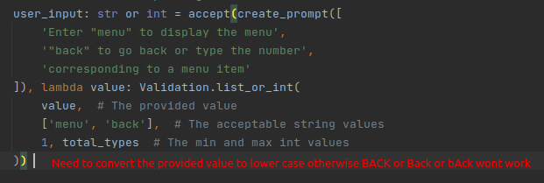

My solution to this issue was to add a call to .lower() onto the end of the user input

This allowed me to provide any combination of case and have it still work as long as it was spelled correctly

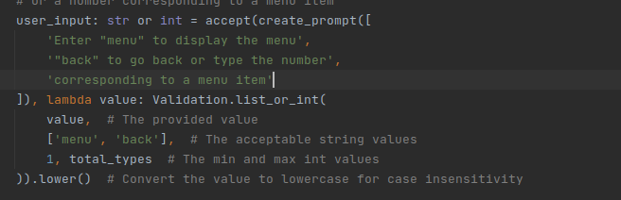

## Bug 2

*ASCII color formatting codes on windows*

Because my usual development environment is running on a linux operating system (Ubuntu) I was able to freely use ASCII colour formatting codes to change the color of

Sections of the terminal however I found that when I attempted to run the program on windows both powershell and command prompt instead chose to render the characters because they do not support this functionality

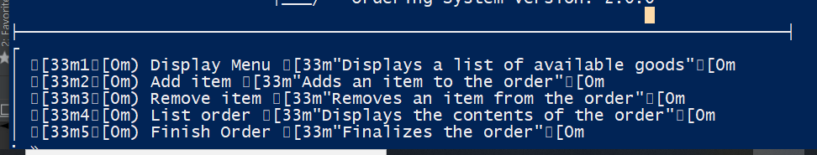

To get around this issue I implemented an operating system check

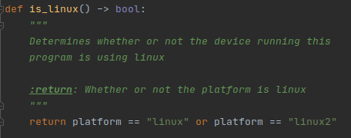

This code allows the program to still display the ASCII colour formatting on linux computers without breaking on other unsupported platforms

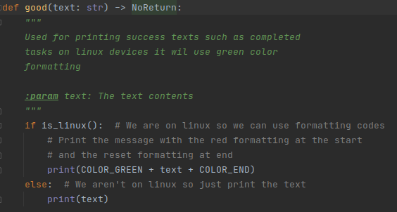

The function is then used like so to only print colour formatting on linux devices